https://www.studytonight.com/computer-architecture/pipelining:
Contents
What is Pipelining? 4
Types of Pipeline 4
Arithmetic Pipeline 5
Instruction Pipeline 5
Pipeline Conflicts 5
1. Timing Variations 5
2. Data Hazards 6
3. Branching 6
4. Interrupts 6
5. Data Dependency 6
Advantages of Pipelining 6
Disadvantages of Pipelining 6
Vector(Array) Processing and Superscalar Processors 7
What is Vector(Array) Processing? 7
Applications of Vector Processors 8
Superscalar Processors 8
Vector(Array) Processor and its Types 9
Types of Array Processors 9
Attached Array Processors 9
SIMD Array Processors 10
Why use the Array Processor 11
Computer Architecture: Input/Output Organisation 11
Input/Output Subsystem 11
Peripheral Devices 12
Interfaces 12
Modes of I/O Data Transfer 13
Programmed I/O 13
Interrupt Initiated I/O 13
Direct Memory Access 13
Computer Architecture: Input/Output Processor 14
Block Diagram Of I/O Processor 14
Computer Architecture: Interrupts 15
Priority Interrupt 16
Types of Interrupts: 16
Hardware Interrupts 16
Software Interrupts 17
Daisy Chaining Priority 17
Serial Data Communication 18
Data Communication Processor 18
What is Modem? 18
Modes Of Transmission 19
What are Protocols? 20
Types of Protocols 20
Input/Output Channels 20
IBM 370 I/O Channel 21
Categories of I/O Channels 21
What is Interleaved Memory? 22
Types of Interleaving 23
2-Way Interleaved 23
4-Way Interleaved 24
RISC and CISC Processors 24
RISC Processor 24
CISC Processor 24
Difference Between CISC and RISC 24
Booth's Multiplication Algorithm 25
Design of Control Unit 26
Hardwired Control Unit 27
Microprogrammed Control Unit 27
Difference between Hardwired Control and Microprogrammed Control 28

What is Pipelining?
Pipelining is the process of accumulating instruction from the processor through a pipeline. It allows storing and executing instructions in an orderly process. It is also known as pipeline processing.
Pipelining is a technique where multiple instructions are overlapped during execution. Pipeline is divided into stages and these stages are connected with one another to form a pipe like structure. Instructions enter from one end and exit from another end.
Pipelining increases the overall instruction throughput.
In pipeline system, each segment consists of an input register followed by a combinational circuit. The register is used to hold data and combinational circuit performs operations on it. The output of combinational circuit is applied to the input register of the next segment.
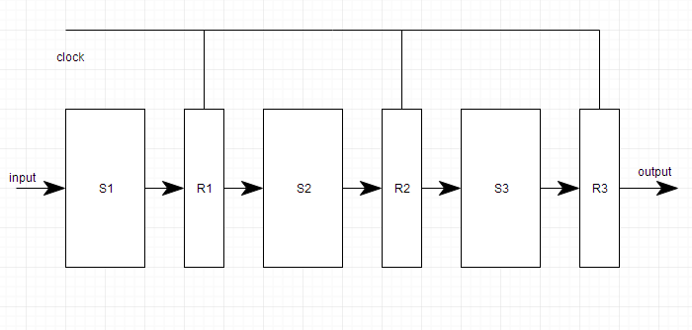
Pipeline system is like the modern day assembly line setup in factories. For example in a car manufacturing industry, huge assembly lines are setup and at each point, there are robotic arms to perform a certain task, and then the car moves on ahead to the next arm.

Types of Pipeline
It is divided into 2 categories:
- Arithmetic Pipeline
- Instruction Pipeline

Arithmetic Pipeline
Arithmetic pipelines are usually found in most of the computers. They are used for floating point operations, multiplication of fixed point numbers etc. For example: The input to the Floating Point Adder pipeline is:
X = A*2^a
Y = B*2^b
Here A and B are mantissas (significant digit of floating point numbers), while a and b are exponents.
The floating point addition and subtraction is done in 4 parts:
- Compare the exponents.
- Align the mantissas.
- Add or subtract mantissas
- Produce the result.
Registers are used for storing the intermediate results between the above operations.

Instruction Pipeline
In this a stream of instructions can be executed by overlapping fetch, decode and execute phases of an instruction cycle. This type of technique is used to increase the throughput of the computer system.
An instruction pipeline reads instruction from the memory while previous instructions are being executed in other segments of the pipeline. Thus we can execute multiple instructions simultaneously. The pipeline will be more efficient if the instruction cycle is divided into segments of equal duration.

Pipeline Conflicts
There are some factors that cause the pipeline to deviate its normal performance. Some of these factors are given below:

1. Timing Variations
All stages cannot take same amount of time. This problem generally occurs in instruction processing where different instructions have different operand requirements and thus different processing time.

2. Data Hazards
When several instructions are in partial execution, and if they reference same data then the problem arises. We must ensure that next instruction does not attempt to access data before the current instruction, because this will lead to incorrect results.

3. Branching
In order to fetch and execute the next instruction, we must know what that instruction is. If the present instruction is a conditional branch, and its result will lead us to the next instruction, then the next instruction may not be known until the current one is processed.

4. Interrupts
Interrupts set unwanted instruction into the instruction stream. Interrupts effect the execution of instruction.

5. Data Dependency
It arises when an instruction depends upon the result of a previous instruction but this result is not yet available.

Advantages of Pipelining
- The cycle time of the processor is reduced.
- It increases the throughput of the system
- It makes the system reliable.

Disadvantages of Pipelining
- The design of pipelined processor is complex and costly to manufacture.
- The instruction latency is more.

Vector(Array) Processing and Superscalar Processors
A Scalar processor is a normal processor, which works on simple instruction at a time, which operates on single data items. But in today's world, this technique will prove to be highly inefficient, as the overall processing of instructions will be very slow.

What is Vector(Array) Processing?
There is a class of computational problems that are beyond the capabilities of a conventional computer. These problems require vast number of computations on multiple data items, that will take a conventional computer(with scalar processor) days or even weeks to complete.
Such complex instructions, which operates on multiple data at the same time, requires a better way of instruction execution, which was achieved by Vector processors.
Scalar CPUs can manipulate one or two data items at a time, which is not very efficient. Also, simple instructions like ADD A to B, and store into C are not practically efficient.
Addresses are used to point to the memory location where the data to be operated will be found, which leads to added overhead of data lookup. So until the data is found, the CPU would be sitting ideal, which is a big performance issue.
Hence, the concept of Instruction Pipeline comes into picture, in which the instruction passes through several sub-units in turn. These sub-units perform various independent functions, for example: the first one decodes the instruction, the second sub-unit fetches the data and the third sub-unit performs the math itself. Therefore, while the data is fetched for one instruction, CPU does not sit idle, it rather works on decoding the next instruction set, ending up working like an assembly line.
Vector processor, not only use Instruction pipeline, but it also pipelines the data, working on multiple data at the same time.
A normal scalar processor instruction would be ADD A, B, which leads to addition of two operands, but what if we can instruct the processor to ADD a group of numbers(from 0 to n memory location) to another group of numbers(lets say, n to k memory location). This can be achieved by vector processors.
In vector processor a single instruction, can ask for multiple data operations, which saves time, as instruction is decoded once, and then it keeps on operating on different data items.

Applications of Vector Processors
Computer with vector processing capabilities are in demand in specialized applications. The following are some areas where vector processing is used:
- Petroleum exploration.
- Medical diagnosis.
- Data analysis.
- Weather forecasting.
- Aerodynamics and space flight simulations.
- Image processing.
- Artificial intelligence.

Superscalar Processors
It was first invented in 1987. It is a machine which is designed to improve the performance of the scalar processor. In most applications, most of the operations are on scalar quantities. Superscalar approach produces the high performance general purpose processors.
The main principle of superscalar approach is that it executes instructions independently in different pipelines. As we already know, that Instruction pipelining leads to parallel processing thereby speeding up the processing of instructions. In Superscalar processor, multiple such pipelines are introduced for different operations, which further improves parallel processing.
There are multiple functional units each of which is implemented as a pipeline. Each pipeline consists of multiple stages to handle multiple instructions at a time which support parallel execution of instructions.
It increases the throughput because the CPU can execute multiple instructions per clock cycle. Thus, superscalar processors are much faster than scalar processors.
A scalar processor works on one or two data items, while the vector processor works with multiple data items. A superscalar processor is a combination of both. Each instruction processes one data item, but there are multiple execution units within each CPU thus multiple instructions can be processing separate data items concurrently.
While a superscalar CPU is also pipelined, there are two different performance enhancement techniques. It is possible to have a non-pipelined superscalar CPU or pipelined non-superscalar CPU. The superscalar technique is associated with some characteristics, these are:
- Instructions are issued from a sequential instruction stream.
- CPU must dynamically check for data dependencies.
- Should accept multiple instructions per clock cycle.

Vector(Array) Processor and its Types
Array processors are also known as multiprocessors or vector processors. They perform computations on large arrays of data. Thus, they are used to improve the performance of the computer.

Types of Array Processors
There are basically two types of array processors:
- Attached Array Processors
- SIMD Array Processors

Attached Array Processors
An attached array processor is a processor which is attached to a general purpose computer and its purpose is to enhance and improve the performance of that computer in numerical computational tasks. It achieves high performance by means of parallel processing with multiple functional units.
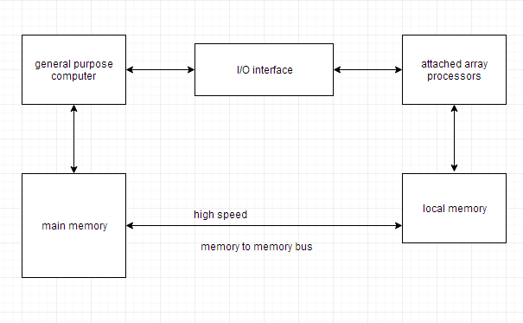

SIMD Array Processors
SIMD is the organization of a single computer containing multiple processors operating in parallel. The processing units are made to operate under the control of a common control unit, thus providing a single instruction stream and multiple data streams.
A general block diagram of an array processor is shown below. It contains a set of identical processing elements (PE's), each of which is having a local memory M. Each processor element includes an ALU and registers. The master control unit controls all the operations of the processor elements. It also decodes the instructions and determines how the instruction is to be executed.
The main memory is used for storing the program. The control unit is responsible for fetching the instructions. Vector instructions are send to all PE's simultaneously and results are returned to the memory.
The best known SIMD array processor is the ILLIAC IV computer developed by the Burroughs corps. SIMD processors are highly specialized computers. They are only suitable for numerical problems that can be expressed in vector or matrix form and they are not suitable for other types of computations.
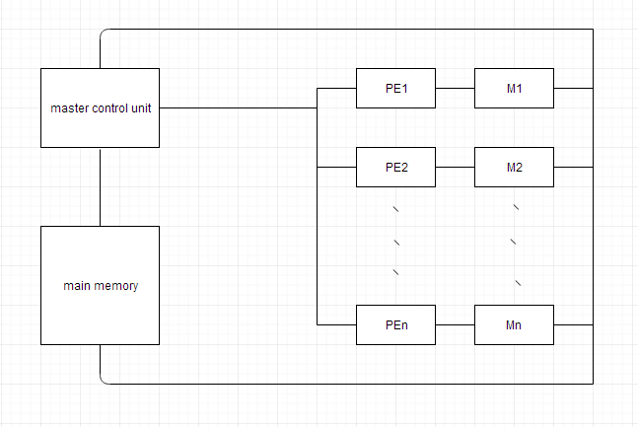

Why use the Array Processor
- Array processors increases the overall instruction processing speed.
- As most of the Array processors operates asynchronously from the host CPU, hence it improves the overall capacity of the system.
- Array Processors has its own local memory, hence providing extra memory for systems with low memory.

Computer Architecture: Input/Output Organisation
In this tutorial we will learn about how Input and Output is handled in a computer system.

Input/Output Subsystem
The I/O subsystem of a computer provides an efficient mode of communication between the central system and the outside environment. It handles all the input-output operations of the computer system.

Peripheral Devices
Input or output devices that are connected to computer are called peripheral devices. These devices are designed to read information into or out of the memory unit upon command from the CPU and are considered to be the part of computer system. These devices are also called peripherals.
For example: Keyboards, display units and printers are common peripheral devices.
There are three types of peripherals:
- Input peripherals : Allows user input, from the outside world to the computer. Example: Keyboard, Mouse etc.
- Output peripherals: Allows information output, from the computer to the outside world. Example: Printer, Monitor etc
- Input-Output peripherals: Allows both input(from outised world to computer) as well as, output(from computer to the outside world). Example: Touch screen etc.

Interfaces
Interface is a shared boundary btween two separate components of the computer system which can be used to attach two or more components to the system for communication purposes.
There are two types of interface:
- CPU Inteface
- I/O Interface
Let's understand the I/O Interface in details,

Input-Output Interface
Peripherals connected to a computer need special communication links for interfacing with CPU. In computer system, there are special hardware components between the CPU and peripherals to control or manage the input-output transfers. These components are called input-output interface units because they provide communication links between processor bus and peripherals. They provide a method for transferring information between internal system and input-output devices.

Modes of I/O Data Transfer
Data transfer between the central unit and I/O devices can be handled in generally three types of modes which are given below:
- Programmed I/O
- Interrupt Initiated I/O
- Direct Memory Access

Programmed I/O
Programmed I/O instructions are the result of I/O instructions written in computer program. Each data item transfer is initiated by the instruction in the program.
Usually the program controls data transfer to and from CPU and peripheral. Transferring data under programmed I/O requires constant monitoring of the peripherals by the CPU.

Interrupt Initiated I/O
In the programmed I/O method the CPU stays in the program loop until the I/O unit indicates that it is ready for data transfer. This is time consuming process because it keeps the processor busy needlessly.
This problem can be overcome by using interrupt initiated I/O. In this when the interface determines that the peripheral is ready for data transfer, it generates an interrupt. After receiving the interrupt signal, the CPU stops the task which it is processing and service the I/O transfer and then returns back to its previous processing task.

Direct Memory Access
Removing the CPU from the path and letting the peripheral device manage the memory buses directly would improve the speed of transfer. This technique is known as DMA.
In this, the interface transfer data to and from the memory through memory bus. A DMA controller manages to transfer data between peripherals and memory unit.
Many hardware systems use DMA such as disk drive controllers, graphic cards, network cards and sound cards etc. It is also used for intra chip data transfer in multicore processors. In DMA, CPU would initiate the transfer, do other operations while the transfer is in progress and receive an interrupt from the DMA controller when the transfer has been completed.
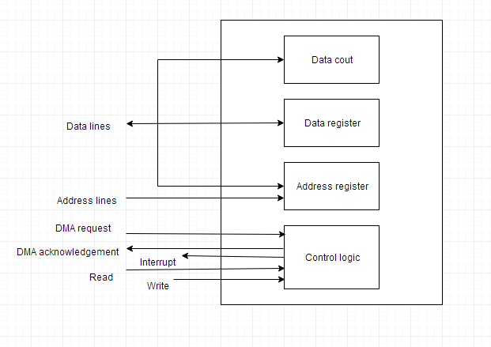
Above figure shows block diagram of DMA

Computer Architecture: Input/Output Processor
An input-output processor (IOP) is a processor with direct memory access capability. In this, the computer system is divided into a memory unit and number of processors.
Each IOP controls and manage the input-output tasks. The IOP is similar to CPU except that it handles only the details of I/O processing. The IOP can fetch and execute its own instructions. These IOP instructions are designed to manage I/O transfers only.

Block Diagram Of I/O Processor
Below is a block diagram of a computer along with various I/O Processors. The memory unit occupies the central position and can communicate with each processor.
The CPU processes the data required for solving the computational tasks. The IOP provides a path for transfer of data between peripherals and memory. The CPU assigns the task of initiating the I/O program.
The IOP operates independent from CPU and transfer data between peripherals and memory.
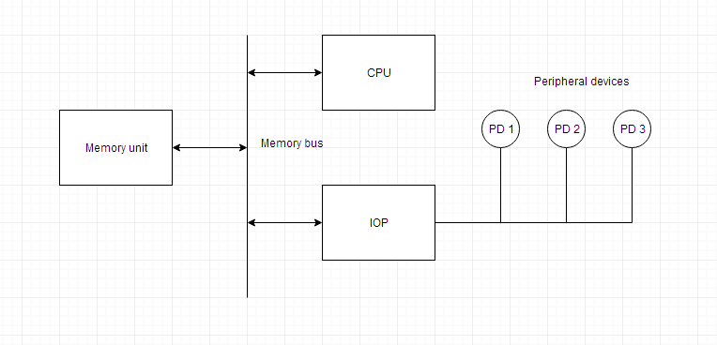

The communication between the IOP and the devices is similar to the program control method of transfer. And the communication with the memory is similar to the direct memory access method.
In large scale computers, each processor is independent of other processors and any processor can initiate the operation.
The CPU can act as master and the IOP act as slave processor. The CPU assigns the task of initiating operations but it is the IOP, who executes the instructions, and not the CPU. CPU instructions provide operations to start an I/O transfer. The IOP asks for CPU through interrupt.
Instructions that are read from memory by an IOP are also called commands to distinguish them from instructions that are read by CPU. Commands are prepared by programmers and are stored in memory. Command words make the program for IOP. CPU informs the IOP where to find the commands in memory.

Computer Architecture: Interrupts
Data transfer between the CPU and the peripherals is initiated by the CPU. But the CPU cannot start the transfer unless the peripheral is ready to communicate with the CPU. When a device is ready to communicate with the CPU, it generates an interrupt signal. A number of input-output devices are attached to the computer and each device is able to generate an interrupt request.
The main job of the interrupt system is to identify the source of the interrupt. There is also a possibility that several devices will request simultaneously for CPU communication. Then, the interrupt system has to decide which device is to be serviced first.

Priority Interrupt
A priority interrupt is a system which decides the priority at which various devices, which generates the interrupt signal at the same time, will be serviced by the CPU. The system has authority to decide which conditions are allowed to interrupt the CPU, while some other interrupt is being serviced. Generally, devices with high speed transfer such as magnetic disks are given high priority and slow devices such as keyboards are given low priority.
When two or more devices interrupt the computer simultaneously, the computer services the device with the higher priority first.

Types of Interrupts:
Following are some different types of interrupts:

Hardware Interrupts
When the signal for the processor is from an external device or hardware then this interrupts is known as hardware interrupt.
Let us consider an example: when we press any key on our keyboard to do some action, then this pressing of the key will generate an interrupt signal for the processor to perform certain action. Such an interrupt can be of two types:
- Maskable Interrupt
The hardware interrupts which can be delayed when a much high priority interrupt has occurred at the same time.
- Non Maskable Interrupt
The hardware interrupts which cannot be delayed and should be processed by the processor immediately.

Software Interrupts
The interrupt that is caused by any internal system of the computer system is known as a software interrupt. It can also be of two types:
- Normal Interrupt
The interrupts that are caused by software instructions are called normal software interrupts.
- Exception
Unplanned interrupts which are produced during the execution of some program are called exceptions, such as division by zero.

Daisy Chaining Priority
This way of deciding the interrupt priority consists of serial connection of all the devices which generates an interrupt signal. The device with the highest priority is placed at the first position followed by lower priority devices and the device which has lowest priority among all is placed at the last in the chain.
In daisy chaining system all the devices are connected in a serial form. The interrupt line request is common to all devices. If any device has interrupt signal in low level state then interrupt line goes to low level state and enables the interrupt input in the CPU. When there is no interrupt the interrupt line stays in high level state. The CPU respond to the interrupt by enabling the interrupt acknowledge line. This signal is received by the device 1 at its PI input. The acknowledge signal passes to next device through PO output only if device 1 is not requesting an interrupt.
The following figure shows the block diagram for daisy chaining priority system.
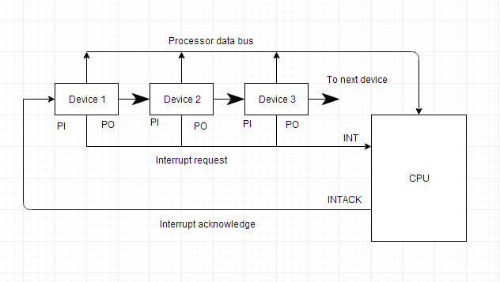

Serial Data Communication
Lets' start by understanding what Data communication processors are,

Data Communication Processor
A data communication processor is an I/O processor that distributes and collects data from numerous remote terminals connected through telephone and other communication lines to the computer. It is a specialized I/O processor designed to communicate with data communication networks.
Such a communication network consists of variety of devices such as printers, display devices, digital sensors etc. serving many users at once. The data communication processor communicates with each terminal through a single pair of wire. It also communicates with CPU and memory in the same manner as any I/O processor does.

What is Modem?
In a Data Communication Network, the remote terminals are connected to the data communication processor through telephone lines or other wires. Such telephone lines are specially designed for voice communication and computers use them to communicate in digital signals, therefore some conversion is required. These conversions are called modem (modulator-demodulator).
A modem converts digital signal into audio tones to be transmitted over telephone lines and also converts audio tones into digital signal for machine use.

Modes Of Transmission
Data can be transmitted between 2 points by three different modes:

Simplex
A simplex line carries information in one direction only. In this mode receiver cannot communicate with the sender to indicate the occurrence of errors that means only sender can send data but receiver cannot. For example: Radio and Television Broadcasting.
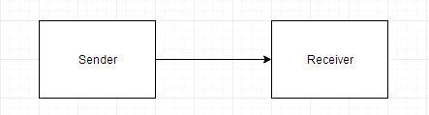

Half Duplex
In half duplex mode, system is capable of transmitting data in both directions but data can be transmitted in one direction only at a time. A pair of wires is needed for this mode. For example: Walkie - Talkie.
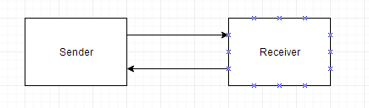
In this mode data can be send and received in both directions simultaneously. In this four wire link is used. For example: Video Calling, Audio calling etc.
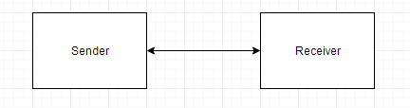

What are Protocols?
The communication lines, modems and other devices used in any transmission are collectively called a Data Link. The orderly transmission of data in a data link can be accomplished by a protocol.
A Protocol is a set of rules that are followed by interconnecting devices to ensure that all data is passed correctly without any error.

Types of Protocols
There are two types of protocols:

Character Oriented Protocol
It is based on the binary code of character set. The code is mostly used in ASCII. It includes upper case and lower case letters, numerals and variety of special symbols. The characters that control the transmission is called communication control characters.

Bit Oriented Protocol
It does not use characters in its control field and is independent of any code. It allows the transmission of serial bit stream of any length without the implication of character boundaries.

Input/Output Channels
A channel is an independent hardware component that co-ordinate all I/O to a set of controllers. Computer systems that use I/O channel have special hardware components that handle all I/O operations.
Channels use separate, independent and low cost processors for its functioning which are called Channel Processors.
Channel processors are simple, but contains sufficient memory to handle all I/O tasks. When I/O transfer is complete or an error is detected, the channel controller communicates with the CPU using an interrupt, and informs CPU about the error or the task completion.
Each channel supports one or more controllers or devices. Channel programs contain list of commands to the channel itself and for various connected controllers or devices. Once the operating system has prepared a list of I/O commands, it executes a single I/O machine instruction to initiate the channel program, the channel then assumes control of the I/O operations until they are completed.

IBM 370 I/O Channel
The I/O processor in the IBM 370 computer is called a Channel. A computer system configuration includes a number of channels which are connected to one or more I/O devices.

Categories of I/O Channels
Following are the different categories of I/O channels:

Multiplexer
The Multiplexer channel can be connected to a number of slow and medium speed devices. It is capable of operating number of I/O devices simultaneously.

Selector
This channel can handle only one I/O operation at a time and is used to control one high speed device at a time.

Block-Multiplexer
It combines the features of both multiplexer and selector channels.

The CPU directly can communicate with the channels through control lines. Following diagram shows the word format of channel operation.
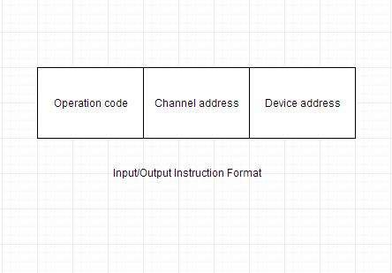
The computer system may have number of channels and each is assigned an address. Each channel may be connected to several devices and each device is assigned an address.

What is Interleaved Memory?
It is a technique for compensating the relatively slow speed of DRAM(Dynamic RAM). In this technique, the main memory is divided into memory banks which can be accessed individually without any dependency on the other.
For example: If we have 4 memory banks(4-way Interleaved memory), with each containing 256 bytes, then, the Block Oriented scheme(no interleaving), will assign virtual address 0 to 255 to the first bank, 256 to 511 to the second bank. But in Interleaved memory, virtual address 0 will be with the first bank, 1 with the second memory bank, 2 with the third bank and 3 with the fourt, and then 4 with the first memory bank again.
Hence, CPU can access alternate sections immediately without waiting for memory to be cached. There are multiple memory banks which take turns for supply of data.
Memory interleaving is a technique for increasing memory speed. It is a process that makes the system more efficient, fast and reliable.
For example: In the above example of 4 memory banks, data with virtual address 0, 1, 2 and 3 can be accessed simultaneously as they reside in spearate memory banks, hence we do not have to wait for completion of a data fetch, to begin with the next.
An interleaved memory with n banks is said to be n-way interleaved. In an interleaved memory system, there are still two banks of DRAM but logically the system seems one bank of memory that is twice as large.
In the interleaved bank representation below with 2 memory banks, the first long word of bank 0 is floowed by that of bank 1, which is followed by the second long word of bank 0, which is followed by the second long word of bank 1 and so on.
The following figure shows the organization of two physical banks of n long words. All even long words of logical bank are located in physical bank 0 and all odd long words are located in physical bank 1.
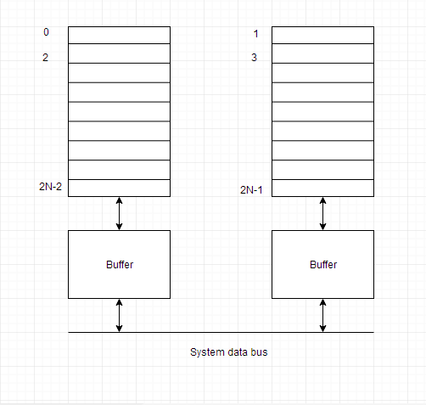

Types of Interleaving
There are two methods for interleaving a memory:

2-Way Interleaved
Two memory blocks are accessed at same time for writing and reading operations.

4-Way Interleaved
Four memory blocks are accessed at the same time.

RISC and CISC Processors
In this tutorial, we will learn about RISC Processor and CISC Processor and difference between them.

RISC Processor
It is known as Reduced Instruction Set Computer. It is a type of microprocessor that has a limited number of instructions. They can execute their instructions very fast because instructions are very small and simple.
RISC chips require fewer transistors which make them cheaper to design and produce. In RISC, the instruction set contains simple and basic instructions from which more complex instruction can be produced. Most instructions complete in one cycle, which allows the processor to handle many instructions at same time.
In this instructions are register based and data transfer takes place from register to register.

CISC Processor
- It is known as Complex Instruction Set Computer.
- It was first developed by Intel.
- It contains large number of complex instructions.
- In this instructions are not register based.
- Instructions cannot be completed in one machine cycle.
- Data transfer is from memory to memory.
- Micro programmed control unit is found in CISC.
- Also they have variable instruction formats.

Difference Between CISC and RISC
Architectural Characterstics | Complex Instruction Set Computer(CISC) | Reduced Instruction Set Computer(RISC)
Instruction size and format | Large set of instructions with variable formats (16-64 bits per instruction). | Small set of instructions with fixed format (32 bit).
Data transfer | Memory to memory. | Register to register.
CPU control | Most micro coded using control memory (ROM) but modern CISC use hardwired control. | Mostly hardwired without control memory.
Instruction type | Not register based instructions. | Register based instructions.
Memory access | More memory access. | Less memory access.
Clocks | Includes multi-clocks. | Includes single clock.
Instruction nature | Instructions are complex. | Instructions are reduced and simple.

Booth's Multiplication Algorithm
Booth's algorithm is a multiplication algorithm that multiplies two signed binary numbers in 2's compliment notation.
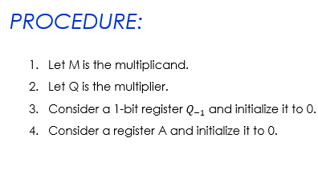
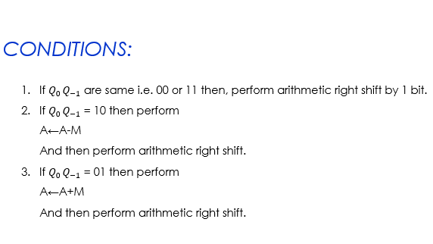
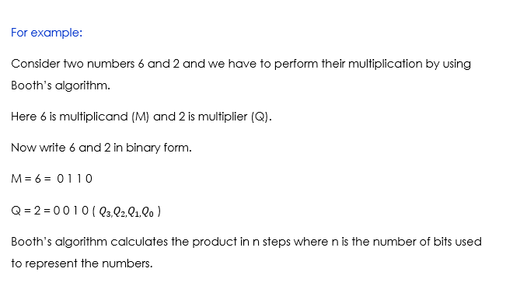
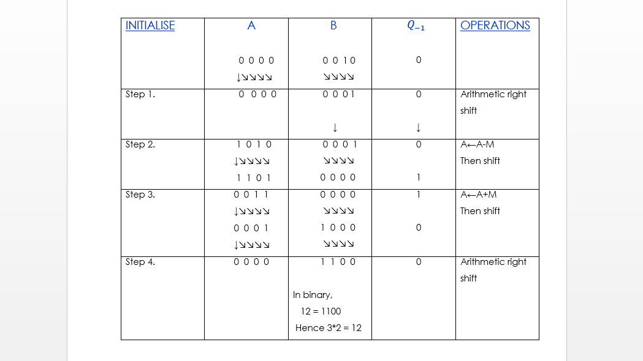

Design of Control Unit
Control unit generates timing and control signals for the operations of the computer. The control unit communicates with ALU and main memory. It also controls the transmission between processor, memory and the various peripherals. It also instructs the ALU which operation has to be performed on data.
Control unit can be designed by two methods which are given below:

Hardwired Control Unit
It is implemented with the help of gates, flip flops, decoders etc. in the hardware. The inputs to control unit are the instruction register, flags, timing signals etc. This organization can be very complicated if we have to make the control unit large.
If the design has to be modified or changed, all the combinational circuits have to be modified which is a very difficult task.
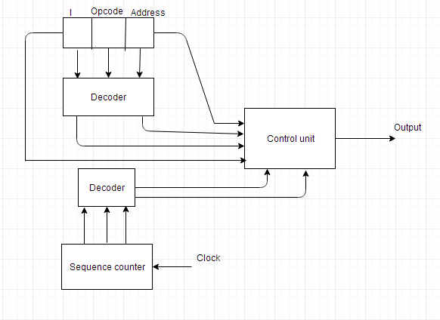

Microprogrammed Control Unit
It is implemented by using programming approach. A sequence of micro operations is carried out by executing a program consisting of micro-instructions. In this organization any modifications or changes can be done by updating the micro program in the control memory by the programmer.

Difference between Hardwired Control and Microprogrammed Control
Hardwired Control | Microprogrammed Control
Technology is circuit based. | Technology is software based.
It is implemented through flip-flops, gates, decoders etc. | Microinstructions generate signals to control the execution of instructions.
Fixed instruction format. | Variable instruction format (16-64 bits per instruction).
Instructions are register based. | Instructions are not register based.
ROM is not used. | ROM is used.
It is used in RISC. | It is used in CISC.
Faster decoding. | Slower decoding.
Difficult to modify. | Easily modified.
Chip area is less. | Chip area is large.

